CLEVELAND MUNICIPAL COURT
HOUSING DIVISION
CUYAHOGA COUNTY, OHIO
JUDGE W. MONÁ SCOTT

_____________ _____________ *

Plaintiff (s), * Case No. ___________________

v. *
MOTION FOR EXEMPTION FROM OH-RESOLVE
__________________________ *

Defendant (s) *

Now comes Plaintiff / Defendant (circle one) ________________________ (name), who respectfully moves this Court for an exemption from OH-Resolve for the following reasons:
_________________________________________________________________________________________________________________________________________________________________________________________________________________________________________________________________________________________________________________________________________________________________________________________________________________________________________
Respectfully Submitted,
________________________________
(Name)
________________________________
(Address)
`________________________________
________________________________
_______________________________
(Phone No. & Email)
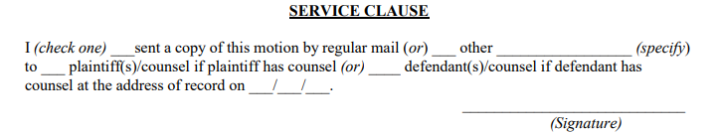 (Phone No.)

